Hello Calum, I have left specific comments on your TMA below, all of which are highlighted in green. I have also left overall comments and feedback on your PT3 form.

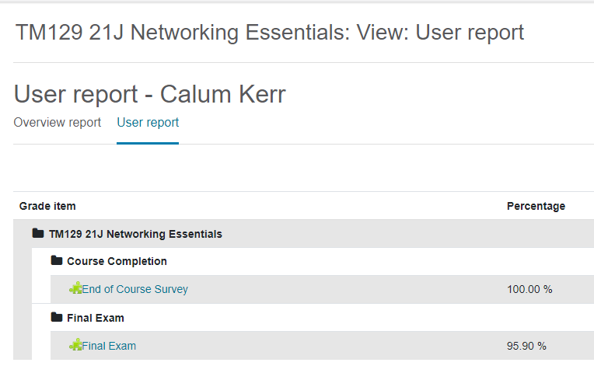**Question 1**

TMA_Q1_Mark = 0.2 x 95.9 = 19.2

Rounded up the final number is **20.**

Good work.

**Question 2**

My finale completion score is 100%

e. Cisco Packet Tracer 8.0.1

Good work.

**Question 3**

1. One advantage is that it can be done remotely, meaning that no person physically needs to change the configuration.

2 marks

1. 11000000 = 128 + 64 = 192.   
   10101000 = 128 + 32 + 8 = 168.   
   01100100 = 64 + 32 + 4 + 100.   
   00001010 = 8 + 2 = 10.   
   Converted IP address is 192.168.100.10  
   4 marks
2. It is a public IP address because it’s not in range of ‘172s’ and ‘192s’.  
   It is a network address because of the first three octets. – 191.11.2

It’s a broadcast address  
It is a B class because the first octet is between 128-191.  
2 marks

1. 100 = 64 + 32 + 4 = 01100100  
   122 = 64 + 32 + 16 + 8 =01111010  
   171 = 128 + 32 + 8 + 2 + 1 =10101011  
   24 = 16 + 8 = 00011000  
   2 marks
3. DoS (Denial of Service) attack is when a threat actor floods a network with traffic so that nothing else can travel through the network. In comparison to a DDoS (Distributed Denial of Service) attack where this damages more powerful because the networks gets flooded with lots of random data simultaneously

3 marks

1. A computer virus is where a program gets changed by the virus and the spread to other programs. An example is ‘MyDoom’, it was spread through email and was the most damaging virus ever.

Compared to viruses a worm is able to use the network to spread to other devices and programs, whilst running on its own. An example is ‘ExploreZip’, this is where it was spread through emails in the spam section.

4 marks

**Question 4**

1. One activity from the ePortfolio was from week 7, (Packet Tracer activity 18.2.6). Evidence of completion:

A Second activity from the ePortfolio was from week 4 (Packet Tracer activity 12.4.4). Evidence of completion:

1. One thing I found challenging was learning all the commands, in general there are a lot, and trying to make sure that they are all correct to the context of the question was quite awkward. There was a lot of back and forth between the Cisco networking page, making suer it’s all correct, and that I was doing the right thing. An interesting part of the course was learning how to configure routers and add things like wireless networks. After learning how to do such things, it got much easier to learn newer things and being able to not look in Cisco for help. This is good as it builds my knowledge and confidence in Packet Tracer. At first glance looking at different things in Packet Tracer seemed very complicated and tricky to learn but it was surprisingly easy to learn, especially after doing practice labs to help my brain recall past questions and activities so that I can become quicker and more skilled. I’ve learned many skills throughout the networking course, one being that I’ve learned my way around Packet Tracer. Being able to confidently know how to configure routers or switches, set wireless devices, and connecting to the internet is a great boost on learning networking skills. Time management was definitely the skill that learned best, spreading the work, and having deadlines was a perfect way to build up this skill.

Good work - 10 marks